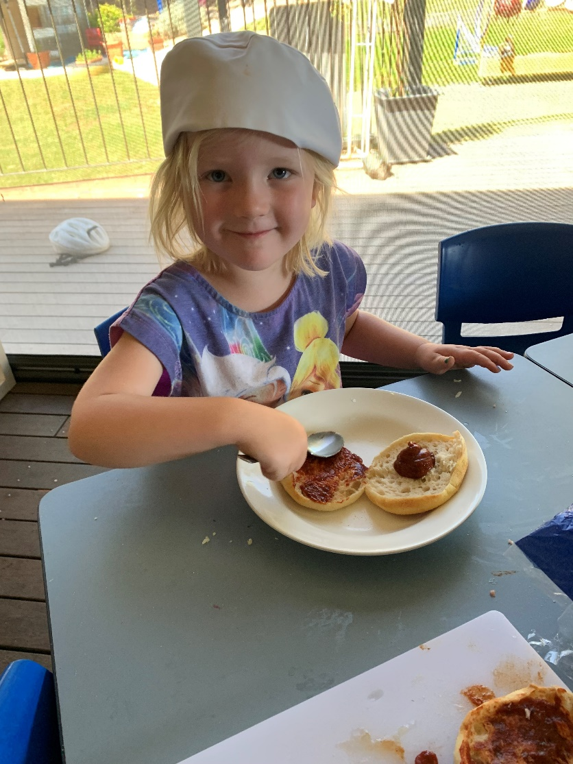
D.I.Y Pizza’s

Ingredients
- Pineapple
- Cabanossi
- Salami
- Snow Pea
- Mixed Tomato’s
- Cheese
- English Muffins

Method

Cut open muffin and squeeze on pizza sauce. Spread pizza sauce and add toppings.
Add cheese and cook in oven for 10 minutes until crispy!
ENJOY!
Apricot Chicken

Ingredients

- 4-5 fresh apricots
- 500g chicken breast/ tenderloins
- 400ml tin apricot nectar
- 1 packet French onion soup mix
- ½ cup plain flour
- Vegetables and rice to serve

Method
- Preheat oven to 180 degrees
- Lightly coat chicken in flour
- Mix together 1 packet French onion soup mix and 400ml apricot nectar
- Pour mixture into casserole dish
- Cook chicken on medium high heat turning when brown.
- Bake for 35-40 minutes until sauce has thickened and vegetables are cooked through
- Serve with Rice and steamed vegetables
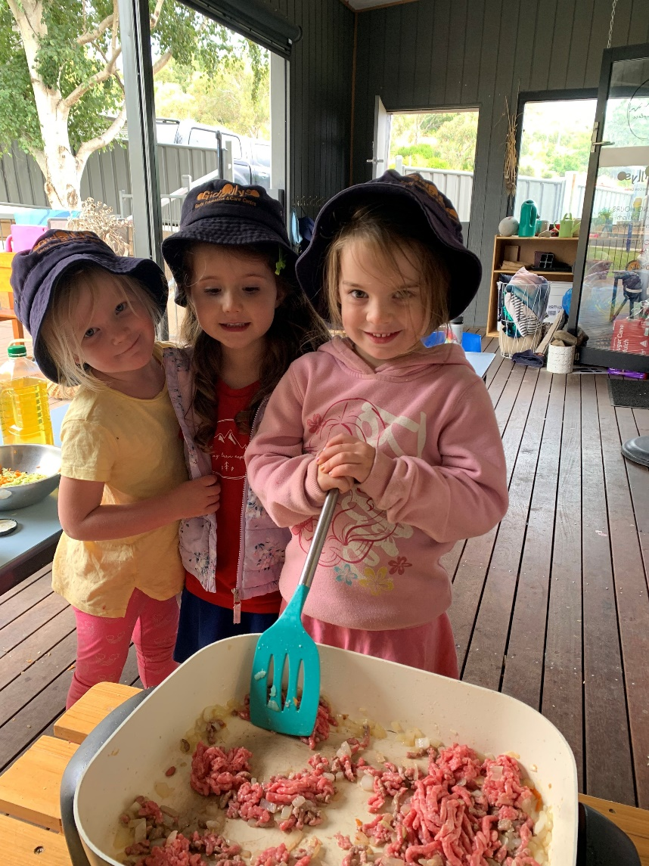
Beef Burgers!
Serve 6 smaller or 4 Large
Ingredients
1 Zucchini grated
1 Carrot grated
1 onion finely diced
1 garlic clove grated
1 cup grated cheese
4tbs tomato paste
500g beef mince
Method
Grate vegetables and dice onion. Add 1tbs oil to medium high pan and cook until softened.
Set aside until cool.
Put mince, cheese and tomato paste into bowl add salt and pepper to season.
Add vegetables to beef mixture and mix together.
Roll into balls and press down to form patty
Cook on medium high heat until cooked flipping halfway.
Serve on English muffin with salads.

